Accessibility basics: Microsoft Word
Contents
Introduction 1
Setting the language 1
MS Word styles 2
Typeface 3
Editing MS Word styles 3
Document navigation 4
Page numbers 4
Captions 4
Alt tags 5
Hyperlinks 6
Add a table of contents 6
Check your document for accessibility 6
Guidance 6

Introduction

To comply with accessibility legislation, all new or substantially altered learning materials need to be accessible. This guide covers the basics of making a Microsoft (MS) Word document accessible. Note: these instructions are for the Office 365 version of MS Word, all University and College machines will be running this version.

Setting the language

One of the first things a screen reader needs to know is the document’s language. Unfortunately, MS Word does not set the language tag. This has to be set for each document.

From the ribbon, click File. From the menu on the left, click Info. In the right-hand column, click the Properties drop down arrow. Click Advanced Properties (Fig. 1). | 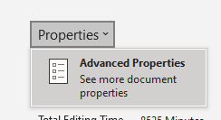  Figure 1: Document advanced properties
The properties box opens. Click the custom tab. In the Name section, scroll down and click Language. In the Value box enter the language of the document, e.g., English or Scottish Gaelic. Click Add. The information will be added to the Properties box (Fig. 2). Click OK.

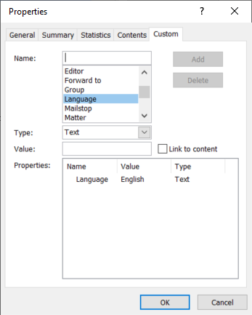
Figure 2: Adding a language tab to the document's properties

MS Word styles

Use MS Word styles to apply formatting. Do not use the formatting icons in the Font section of the Home tab on the ribbon to create headings, subheadings or make changes to text.

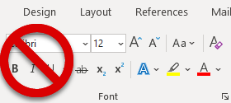
Figure 3: Do not use the icons in the Font section of the ribbon to make formatting changes
All text is by default the Normal style. To add a heading, select your first heading and click Heading 1 in the Styles section on the Home tab on the ribbon. To add a sub heading, select your sub heading and click Heading 2. Note: to make sense for people using screen readers, headings must be hierarchical.

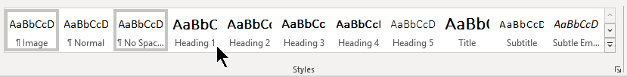
Figure 4: Apply a style

Typeface

UHI’s brand guidelines specify either Arial or Microsoft’s default typeface Calibri.

To meet accessibility requirements, the minimum point size for Normal text should be 12 points. Note Microsoft’s default is 11 points and should be increased. See Editing MS Word styles below for information. It is recommended that the folowing should be used, depending on how many heading levels are in your document:

Title: 18 or 20 points
Heading 1: 16 or 18 points bold
Heading 2: 14 or 16 points bold
Heading 3: 12 or 14 points bold
Heading 4: 12 points bold
Normal text: 12 points, left justified

Editing MS Word styles

If the default styles do not meet your needs, you can modify the default style by creating the heading or normal text you need, according to the point size guidelines above. In this case, you do use the icons in the font sectionon the ribbon (Fig. 1) to create your heading. Once you have applied the correct font, size, colour etc., to your heading, select your heading, right click on the heading style (for example, Heading 1) and click Update Heading 1 to Match Selection. See Customize or create new styles.

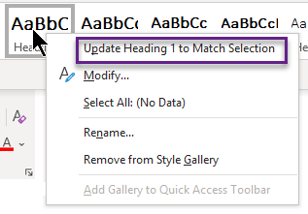
Figure 5: Update Heading 1 to match selection

If you would like your new style to appear in all your new Word documents, right-click it in the Styles gallery, click Modify, and then select New documents based on this template at the bottom of the dialog box.

Note: do not use block capitals, underline headings or text or use italics as this makes it difficult to read. Do not use colour for emphasis. Your normal style should be at least 12 points and left-aligned. If you use a background colour, ensure there is a good contrast between the background and the font colour.

Document navigation

Using MS Styles makes it easy to navigate through your document or change the order. Open the Navigation pane (Ctrl + F), click Headings (Fig. 6). Click on a heading to go to that place in the document. Click and drag a heading to move that section to another place in the document. | 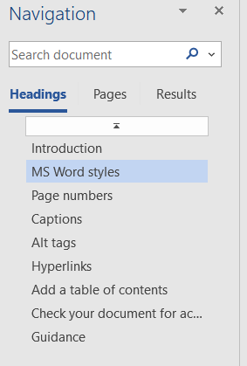  Figure 6: Navigation pane

Page numbers

Page numbers should be added to all documents. On the ribbon, click the Insert tab, in the Header & Footer section click Page Number and select the page number position and type. See Page numbering in Word for more information and fine-tuning.

Captions

All tables, images and equations should have captions. Right-click on the object, select Insert caption, chose Fig, Table or Equation and enter the caption. See Add, format, or delete captions in Word.

Note: the default caption style is italic. Italics should not be used as they are difficult to read. To change the default style, click the options link (arrow, bottom right) in the Styles section on the Home tab.

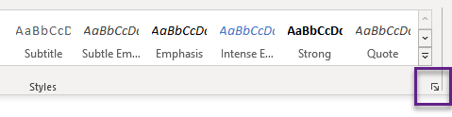
Figure 7: Options link

The Styles pane opens. In the Styles pane, click the down arrow next to Caption, click Modify.

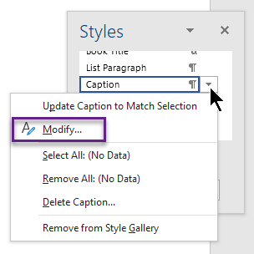
Figure 8: Styles pane

The Modify style box opens. Click the Italic icon to remove the italics, click OK. This changes the style of all your captions.

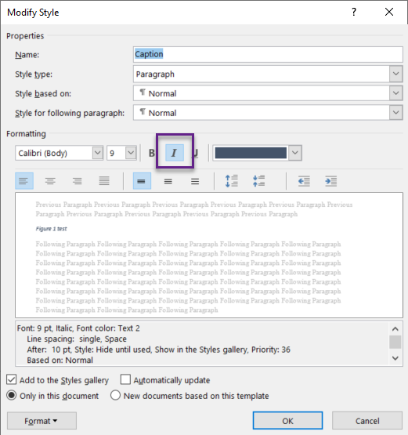
Figure 9: Modify style

Alt tags

If an image is used to convey information that is not in the text (e.g. a table or a chart) , it must have an Alt tag to describe the information the image is conveying. Right-click the image, click Edit Alt tab and add one or two sentences that describes the image or table to someone who is blind.

If the image does not show additional information that is not already covered in the text, or is decorative, right-click the image, click Edit Alt tab and click Mark as decorative.

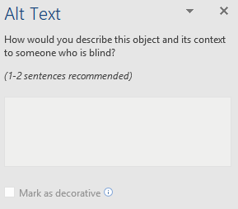
Figure 10: Alt Text box

Hyperlinks

Do not use “click here” when directing people to a hyperlink, the term “click here” does not help someone who is using a screen reader. People who use screenreaders often want to hear what links are on a page. If you use “click here” for all your links, when they ask for a list of links, all they hear are a series of “click heres”. Hyperlinks must always be descriptive.

Add a table of contents

Once you have applied Heading Styles to all of your headings, you can use Word to
generate a table of contents. Click where you want your table of contents. On the ribbon, click the References tab. In the Table of contents section, click Table of contents and select an automatic or manual table.

Check your document for accessibility

MS Word has a built-in accessibility checker which checks for basic accessibility. But it does not pick up everything. On the ribbon, click the Review tab. Click Check Accessibility. The accessibility pane opens with the results. For more information see Improve accessibility with the Accessibility Checker.

Guidance

For more information and guidance on Word accessibility and making all document types accessible, see the Accessibility page on UHI’s Teaching Staff Resources site. The EDU have written some excellent guidance:

- The Accessibility support module.

- Accessibility in digital content (part of UHI's EDU support portal)

- Creating accessible PDFs - links to UHI accessible templates (part of UHI's EDU support portal).

